**Re Framework Project in Ui Path**

# **Which is the business process required in industry?**

The business process is involved and required in industry are

* Linear Process
* Iteration Process
* Transaction Process

**Linear Process:**

It is Step by step process or one by one Process or for given one input and getting the response or for one request one output.

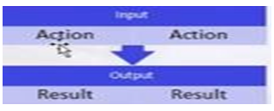

**Iteration Process:**

Iteration is the repetition of a process in order to generate an outcome. The sequence will approach some end point or end value. Each repetition of the process is a single iteration, and the outcome of each iteration is then the starting point of the next iteration.

**Transaction Process:**

A type of processing in which the computer responds immediately to [user](https://www.webopedia.com/definitions/user/) requests. Each request is considered to be a transaction*.* Automatic teller machines for banks are an example of transaction processing.

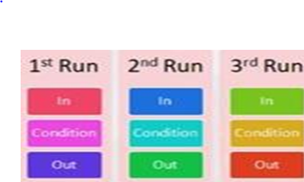

**Ui Path Re Framework Architecture:**

The Re Framework uses the state machine diagram and has the following 4 states:

* Initialize State
* Get Transaction Data State
* Process Transaction State
* End Process State

Please refer below screenshot for better understanding.

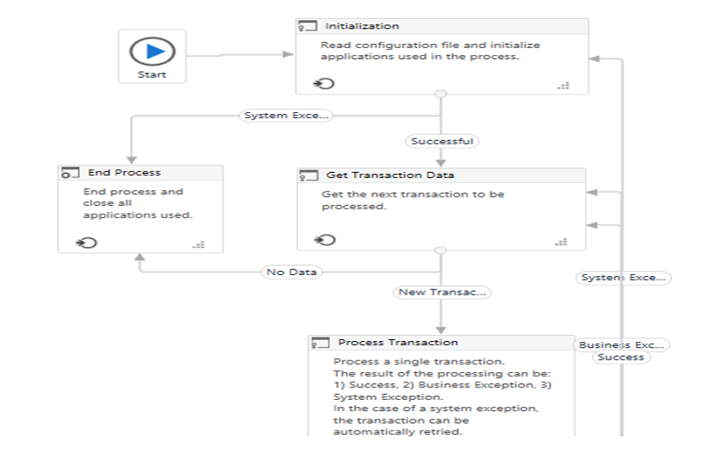

### **Initialize State:**

* Any RPA Project you start in the Re Framework starts in the Initialize state. This is the state, where the robot reads the initial project configuration and initializes the application.
* Once all the configuration is read and the application is initialized and is successful, the transaction goes to the next state i.e., the Get Transaction Data state, else it ends the process by displaying a System Error.

### **Get Transaction Data State****:**

* The Get Transaction Data state is the next state after the Init state. In this state, you have two possibilities. If a new process is retrieved then it goes to the next state i.e., the Process Transaction state, else if all the transactions are processed then it goes to the End Process state.

### **Process Transaction:**

* In the process transaction state, there are three outcomes that can come, i.e either the Success state, Business Transactions and the System Error state. The success state is where the loop is performed and the next transaction data is taken into account.
* The Business Rule Exception occurs, when a specific action is performed after which the execution state goes back to the Get Transaction Data state. The System Error transaction is used to take all the necessary steps through an error. So, in this transaction, all the applications are closed, and the execution loops back to the Initialize state.

### **End Process state:**

* This is the final state in which the transactions enter, after all of them are executed. So, in simple words, it is used to end the process.

How we open Robotic Enterprise Framework?

In the home page of UiPath Studio we will have Robotic Enterprise Framework on the right side.

